19. Designing and implementing a data warehouse for analytics and reporting.
CREATE DATABASE IF NOT EXISTS sales_datawarehouse;
USE sales_datawarehouse;
1.DIMENSION TABLES
DROP TABLE IF EXISTS fact_sales;
DROP TABLE IF EXISTS dim_customer;
DROP TABLE IF EXISTS dim_product;
DROP TABLE IF EXISTS dim_date;
DROP TABLE IF EXISTS dim_location;
Customer Dimension
CREATE TABLE dim_customer(
customer_key INT AUTO_INCREMENT PRIMARY KEY,
customer_id INT,
customer_name VARCHAR(100),
gender VARCHAR(10),
age int
);
Product Dimension
CREATE TABLE dim_product(
product_key INT AUTO_INCREMENT PRIMARY KEY,
product_id INT,
product_name VARCHAR(100),
category VARCHAR(50),
price DECIMAL(10,2)
);
Date Dimension
CREATE TABLE dim_date(
date_key INT PRIMARY KEY,
full_date DATE,
day INT,
month_name VARCHAR(20),
quarter INT,
year int
);
Location Dimension
CREATE TABLE dim_location(
location_key INT AUTO_INCREMENT PRIMARY KEY,
city VARCHAR(50),
state VARCHAR(50),
country VARCHAR(50)
);
2.FACT TABLE
CREATE TABLE fact_sales(
sales_key INT AUTO_INCREMENT PRIMARY KEY,
customer_key INT,
product_key INT,
date_key INT,
location_key INT,
quantity INT,
sales_amount DECIMAL (12,2),
FOREIGN KEY (customer_key)
REFERENCES dim_customer(customer_key),
FOREIGN KEY (product_key)
REFERENCES dim_product(product_key),
FOREIGN KEY (date_key)
REFERENCES dim_date(date_key),
FOREIGN KEY (location_key)
REFERENCES dim_location(location_key)
);
3.INSERT DATA INTO CUSTOMER DIMENSION
INSERT INTO dim_customer
(customer_id, customer_name, gender, age)
VALUES
(101, 'Pratiksha', 'Female', 21),
(102, 'Kunal', 'Male', 25),
(103, 'Aryan', 'Male', 28),
(104, 'Nikita', 'Female', 24),
(105, 'Rohit', 'Male', 30);
SELECT*FROM dim_customer;
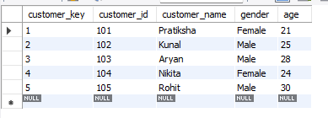
4.INSERT DATA INTO PRODUCT DIMENSION
INSERT INTO dim_product
(product_id, product_name, category, price)
VALUES
(1, 'Laptop', 'Electronics', 55000),
(2, 'Mobile', 'Electronics', 20000),
(3, 'Mouse', 'Accessories', 500),
(4, 'Keyboard', 'Accessories', 1200),
(5, 'Headphones', 'Accessories', 1500);
SELECT*FROM dim_product;
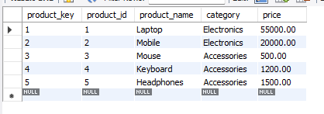
5.INSERT DATA INTO DATE DIMENSION
INSERT INTO dim_date1
(date_key, full_date, day, month, month_name, quarter, year)
VALUES
(20260105, '2026-01-05', 5, 1, 'January', 1, 2026),
(20260110, '2026-01-10', 10, 1, 'January', 1, 2026),
(20260205, '2026-02-05', 5, 2, 'February', 1, 2026),
(20260210, '2026-02-10', 10, 2, 'February', 1, 2026),
(20260305, '2026-03-05', 5, 3, 'March', 1, 2026),
(20260310, '2026-03-10', 10, 3, 'March', 1, 2026),
(20260315, '2026-03-15', 15, 3, 'March', 1, 2026);
SELECT*FROM dim_date1;
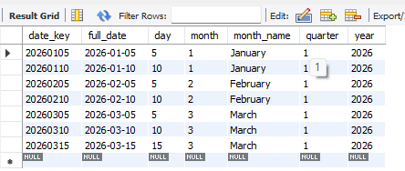
6. INSERT DATA INTO LOCATION DIMENSION
INSERT INTO dim_location
(city, state, country)
VALUES
('Mumbai', 'Maharshtra', 'India'),
('Pune', 'Maharashtra', 'India'),
('Nagpur', 'Maharashtra', 'India');
SELECT*FROM dim_location;
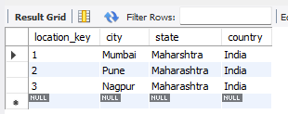

7. INSERT DATA INTO FACT TABLE
INSERT INTO fact_sales
(customer_key, product_key, date_key, location_key,
quantity, sales_amount)
VALUES
(1, 1, 20260105, 1, 1, 55000),
(2, 2, 20260110, 2, 2, 40000),
(3, 3, 20260205, 3, 3, 1500),
(4, 4, 20260210, 2, 2, 2400),
(5, 5, 20260305, 3, 2, 3000),
(1, 2, 20260310, 1, 1, 20000),
(2, 1, 20260315, 2, 1, 55000),
(3, 3, 20260315, 3, 4, 2000),
(4, 2, 20260305, 2, 1, 20000),
(5, 1, 20260310, 3, 1, 55000);
SELECT*FROM fact_sales;

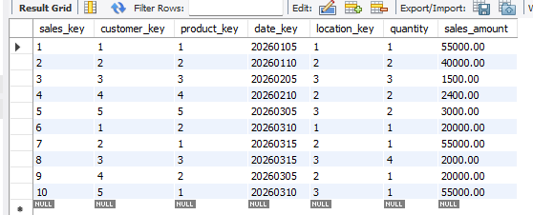
8. ANALYTICS AND REPORTING
Total Sales
SELECT
SUM(sales_amount) AS total_sales
FROM fact_sales;
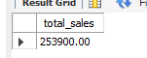
Sales by Product
SELECT
p.product_name,
p.category,
SUM(f.quantity) AS total_quantity,
SUM(f.sales_amount) AS total_sales
FROM fact_sales f
JOIN dim_product p
ON f.product_key=p.product_key
GROUP BY p.product_name,p.category
ORDER BY total_sales DESC;
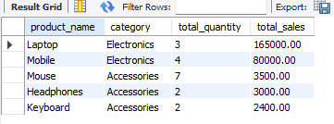
Sales by Customer
SELECT
c.customer_name,
SUM(f.sales_amount) AS total_spending
FROM fact_sales f
JOIN dim_customer c
ON f.customer_key=c.customer_key
GROUP BY c.customer_name
ORDER BY total_spending DESC;
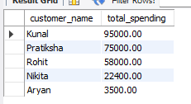
Sales by City
SELECT
l.city,
SUM(f.sales_amount) AS total_sales
FROM fact_sales f
JOIN dim_location l
ON f.location_key = l.location_key
GROUP BY l.city
ORDER BY total_sales DESC;
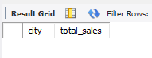
Monthly Sales Report
SELECT
YEAR(d.full_date) AS sales_year,
MONTH(d.full_date) AS sales_month,
MONTHNAME(d.full_date) AS month_name,
SUM(f.sales_amount) AS monthly_sales
FROM fact_sales f
JOIN dim_date d
ON f.date_key = d.date_key
GROUP BY
YEAR(d.full_date),
MONTH(d.full_date),
MONTHNAME(d.full_date)
ORDER BY
sales_year,
sales_month;
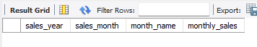
Category-wise Sales
SELECT
p.category,
SUM(f.quantity) AS total_units,
SUM(f.sales_amount) AS total_sales
FROM fact_sales f
JOIN dim_product p
ON f.product_key=p.product_key
GROUP BY p.category
ORDER BY total_sales DESC;

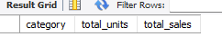
Quarterly Sales Report
SELECT
d.year,
d.quarter,
SUM(f.sales_amount) AS quarterly_sales
FROM fact_sales f
JOIN dim_date d
ON f.date_key=d.date_key
GROUP BY d.year, d.quarter
ORDER BY d.year, d.quarter;

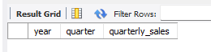
Top Customer
SELECT
c.customer_name,
SUM(f.sales_amount) AS total_sales
FROM fact_sales f
JOIN dim_customer c
ON f.customer_key = c.customer_key
GROUP BY c.customer_name
ORDER BY total_sales DESC
LIMIT 1;
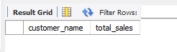
Top Selling Product
SELECT
p.product_name,
SUM(f.quantity) AS units_sold
FROM fact_sales f
JOIN dim_product p
ON f.product_key=p.product_key
GROUP BY p.product_name
ORDER BY units_sold DESC
LIMIT 1;
